Measuring – How Much?

Cutting Verbs

*How to cut* food for recipe

preparation

3

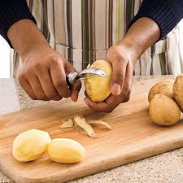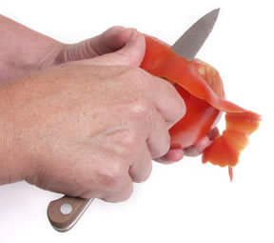

Use a **Paring** Knife:

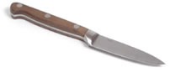

**or:**

##### Peel

##### Peel

Use a **Chef’s** Knife:

small

BIG

#### Dice

##### *Finely* Chop

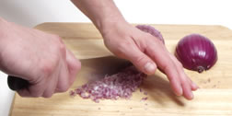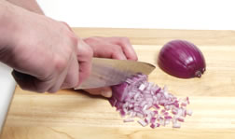

#### Chop / Cube

##### Mince

#### Grate

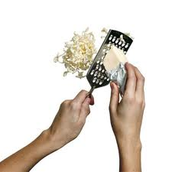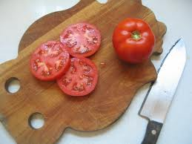

#### Slice

